SETUP INITBAKE WEBSERVICES

- Download or initBake web service or Pull(Clone) the Repository using following command
  - git clone https://github.com/indocosmo-projects/InitBake-Webservice.git
- Create a folder initbakeweb workspace on D

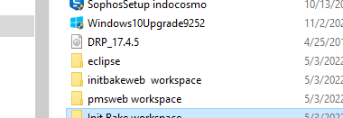

- Extract the downloaded rar file for initweb to initbakeweb workspace on D

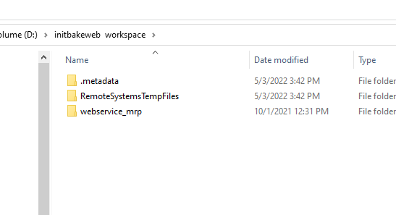

- Open Eclipse with initbakeweb workspace

- Then file-->import-->existing file--->select location then Finish
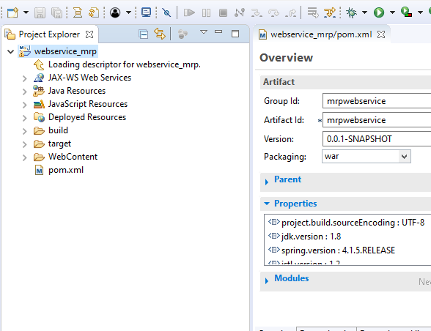

DB Configuration Setup
- Select src and open the database.properties file
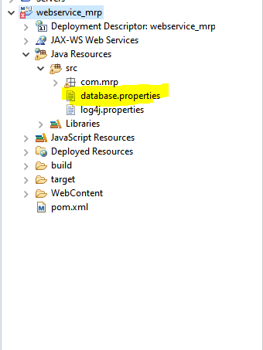
- Give the correct DB details.
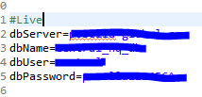
- Save the file

War Build Procedure

- Right click the project --> Select Export-->Choose War file

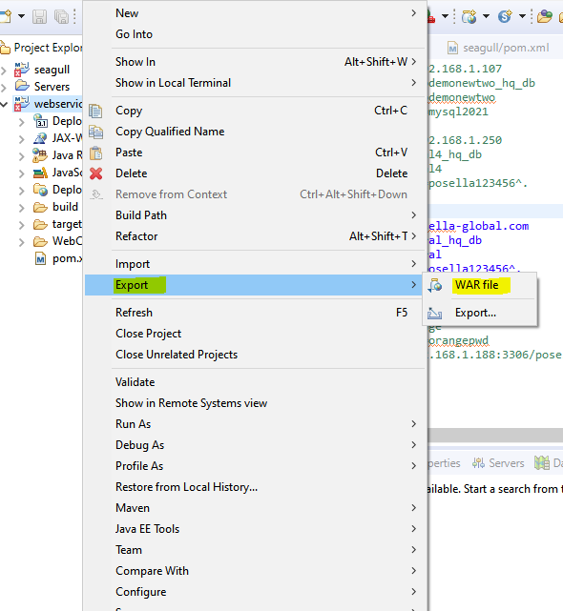

- Select the desired location for war files to save.

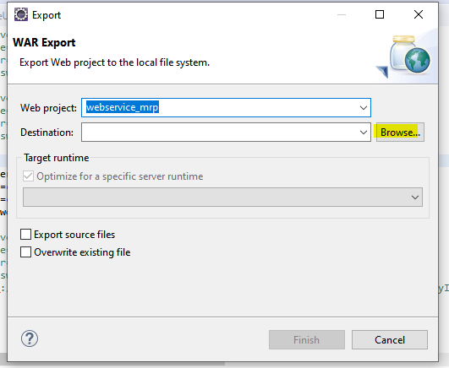

- Save the War file 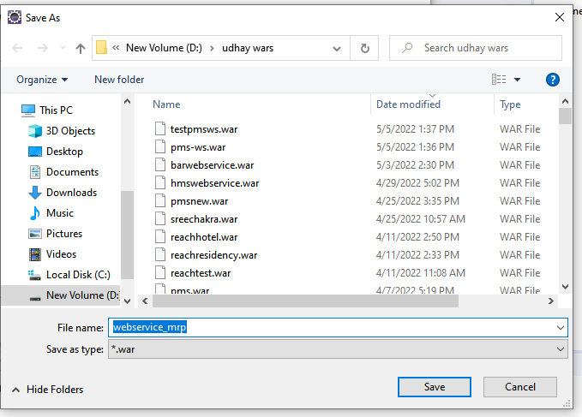

- Click Finish Button
